IASNM Newsletter April, 2012
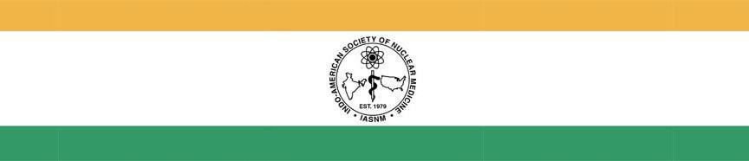
Dear Colleagues,

It is a great pleasure for me, for the second time in the row, to welcome you all to the 2012 Annual Meeting of the Society of Nuclear Medicine. This year we will be gathering in Miami beach, FL. Following the tradition of the past years, we will have the annual reception of the Indo-American Society of Nuclear Medicine (IASNM) on Sunday, June 10, 2012. The venue of the dinner will be notified on this website in the next few days. Please follow the time schedule of 6:30 to 10:00 pm.

This year, IASNM offered an opportunity for two young physician scientists from India to spend few days in Dr. Sam Gambhir’s laboratory (Stanford University, CA). I am excited to observe a lot of interest from participants. The winners of this opportunity will be individually contacted and acknowledged in the IASNM meeting. In addition to this prospect, IASNM will felicitate two best oral presenters of Indian Origin in the Society of Nuclear Medicine. Like last year, the competition is also open to the researchers working in the United States. I especially encourage graduate students, postdoctoral fellows, residents and clinical fellows to note this opportunity by clicking on the link http://iasnm.org/HTML/news_awards.html.

The continuity of our organization is dependent on the contributions from members. Every year we add a generation of nuclear medicine physicians, scientists, pharmacists, technicians and chemists of Indian origin in the profession. However, this growth is not reflected by the number of new members joining this society. While the stagnation in membership is alarming, it also offers us with an opportunity to think what we all can do with the increased membership. The office bearers of the society have special responsibility in this regard, but all professionals of Indo-American origin could help reverse this trend.

I encourage you to please check this web site at a later date for further details about the meeting. We will be glad to provide any further information. I close this newsletter by welcoming you again to Miami Beach, and hope that all of us will have a productive and enjoyable time.

Vibhudutta Awasthi, Ph.D. President vawasthi@ouhsc.edu

www.IASNM.org
1

